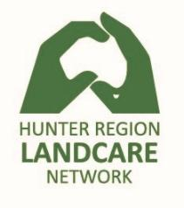
Workshop Evaluation Sheet
Event: Newcastle Landcare Workshop Location: Hunter Wetlands Centre
Date: 23-June-2018
Name:

Overall, how would you rate the Workshop?
Very Poor | 1 | 2 | 3 | 4 | 5 | Very Good

How satisfied were you with?
 | Very Poor |  |  |  | Very Good
Invitation and pre-event organisation | 1 | 2 | 3 | 4 | 5
Organisation of the day | 1 | 2 | 3 | 4 | 5
Catering | 1 | 2 | 3 | 4 | 5
Topics covered | 1 | 2 | 3 | 4 | 5
Pace of the material presented | 1 | 2 | 3 | 4 | 5

What did you like most about the workshop?

What did you dislike about the workshop?

Is there anything else you’d like to share about the Workshop?

Do you have any suggestions for further events?

